PRESS RELEASE
COMMUNICATIONS AND MEDIA TEAM OF THE 43RD ASEAN SUMMIT 2023
No. 49/SP/TKM-ASEAN2023/ENG/9/2023

Cook Islands the First Guest of 43rd ASEAN Summit to Arrive
Jakarta, 4 September 2023 – The invited guests of the 43rd Association of Southeast Asian Nations (ASEAN) Summit have started arriving in Jakarta.
The first guest to arrive was the Prime Minister of Cook Islands, Mark Brown. He arrived at around 20:00 local time at the Soekarno-Hatta Airport in Tangerang, Banten, on Sunday (3 September 2023) evening. Upon disembarking from the plane, PM Mark Brown received a state welcome.
Secretary General of the Ministry of Transportation Novie Riyanto and the Acting Governor of Banten Al Muktabar welcomed the arrival of Mark Brown.

Previously, Indonesian Foreign Affairs Minister Retno L. Marsudi said that Cook Islands was invited for its position as Chair of the Pacific Island Forum (PIF), while Indonesia needs to disseminate information on the roadmap of cooperation between ASEAN countries and the Indo-Pacific countries.
A total of twenty-two countries will attend the 43rd ASEAN Summit, including the eleven ASEAN countries, namely Indonesia, Singapore, Thailand, Malaysia, the Philippines, Brunei Darussalam, Viet Nam, Laos, Myanmar, Cambodia, and Timor-Leste.
Additionally, nine partner countries have been invited, including the Republic of Korea, India, Japan, China, New Zealand, Canada, Australia, Russia, and the United States of America (US).
There are also two additional countries, namely Bangladesh as Chair of the Indian Ocean Rim Association (IORA) and Cook Islands as the Chair of the Pacific Island Forum (PIF).
Indonesia also extended invitations to international organizations such as the United Nations (UN), the World Bank, the International Monetary Fund (IMF), the World Economic Forum, the Indian Ocean Rim Association (IORA), and the Pacific Island Forum (PIF).
The theme for Indonesia’s ASEAN Chairmanship in 2023 is “ASEAN Matters: Epicentrum of Growth”. Through this theme, Indonesia aims to ensure that ASEAN is not only an organization with significance for the region but also the world.
Indonesian President Joko Widodo will open the 43rd ASEAN Summit and chair twelve meetings. The meetings include the 43rd ASEAN Summit plenary and retreat, the 26th ASEAN-China Summit, the 24th ASEAN-South Korea Summit, the 26th ASEAN-Japan Summit, and the 11th ASEAN-US Summit.
The other meetings include the ASEAN-Canada Summit, the 26th ASEAN Plus Three Summit, the 20th ASEAN-India Summit, the 3rd ASEAN-Australia Summit, the 18th East Asia Summit (EAS), and the 13th ASEAN-United Nations (UN) Summit. (Toro/Donna/TR/WW)
***
For more information, please contact:
Director General of Public Information and Communications of the Ministry of Communications and Informatics – Usman Kansong (0816785320).
Get more information at http://asean2023.id, https://infopublik.id/kategori/asean-2023, and https://indonesia.go.id/kategori/ragam-asean-2023

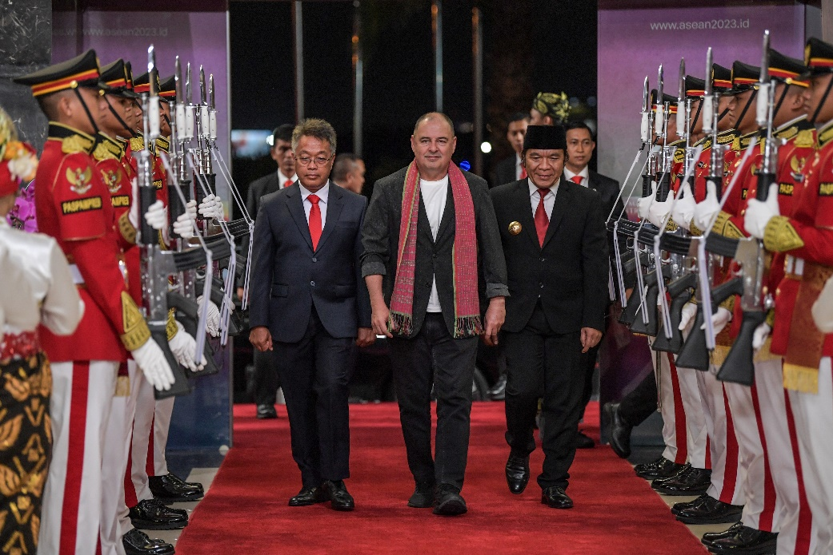
Prime Minister of Cook Islands Mark Brown (center) accompanied by Acting Governor of Banten Al Muktabar (right) and Secretary General of the Ministry of Transportation Novie Riyanto (left) walk towards the VIP Building of Terminal 3 at Soekarno-Hatta Airport in Banten on Sunday (3 September 2023). ANTARA FOTO/Media Center ASEAN 2023/Raisan Al Farisi/aww.

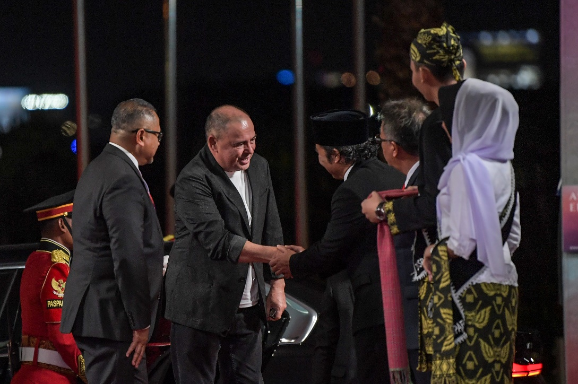

Prime Minister of Cook Islands Mark Brown (second left) shakes hands with the Acting Governor of Banten Al Muktabar (third left) upon arriving at the VIP Building of Terminal 3 at Soekarno-Hatta Airport in Banten on Sunday (3 September 2023). ANTARA FOTO/Media Center ASEAN 2023/Raisan Al Farisi/aww.

